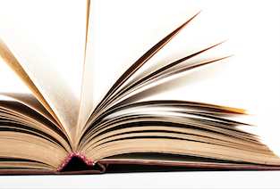
AWAEM BOOK CORNER
We Should All Be Feminists by Chimamanda Ngozi Adichie

by Devjani Das, MD
Northwell Health-Staten Island University Hospital
Email: devdas2@gmail.com Twitter: @ddasmd

What does the word “feminism” mean in this modern world? That is the question at the heart of the much-accomplished author, Chimamanda Ngozi Adichie’s personal essay, which, coincidentally, is an adaptation of her TEDx talk of the same name. Adichie eloquently provides a narrative of her life through personal anecdotes of her childhood experiences in Nigeria and then her experiences as an adult woman, both in Nigeria and the United States. She expounds on the importance of recognizing that the issue of gender rights needs to be addressed specifically towards the question of not just human rights, but specifically what it means to be a woman in society. Her ability to highlight gender issues in more traditional societies where women have for centuries been expected to act a certain way and are often vilified and blamed for crimes committed towards them is both moving and eye opening. Approaching such serious topics with both humor and insightfulness makes this quick read both engaging and entertaining for all. Adichie beautifully illustrates why feminism should not be considered a dirty word, but rather one that should be applied to all humans, regardless of gender. If you have not read any of her other wonderful books to date, this is a great introduction into why she is one of the most celebrated writers today. Even if you don’t have the time to read this short essay, check out her TEDx talk of the same name (https://www.youtube.com/watch?v=hg3umXU_qWc).

