Instructions:  Send this completed form to  amym.nerds@gmail.com  by March 20, 2019 | GROUP REGISTRATION FORM  NERDS19  Wednesday, March 27, 2019  Worcester, MA  http://saem.org/meetings/regional-meetings/new-england | 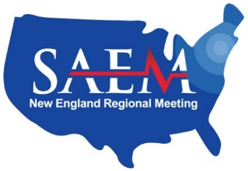

Prices:
Attending/Faculty $175 | Fellow $100 | Research Assistant/Coordinator $50 | Administrator $100
Resident $80 | Allied Health Professional $100 | Student $25 | Other $100

Please list all attendees associated with this registration:
Full Name, Degree  (as will be shown on badge) | E-mail | Fee Category  (attending, resident, etc.) | Fee
Total:

Contact person: |  | Bill to:
Name: |  | Institution / Payee (as shown on check):
E-mail: |  | Mailing Address:
Phone:

Preferred method of payment: | Check (by mail) | Credit Card (by phone)
 | If paying by check, we will send an invoice for payment to the contact person listed above. | If paying by credit card, we will send further instructions to the contact person listed above.

