Instructor Key

Case 1
Just as Janice Langbehn and Lisa Pond were about to depart from Miami on a family cruise with their three children, Pond suddenly collapsed.¹ From the moment Langbehn and the children arrived at Jackson Memorial Hospital, they encountered prejudice and apathy. Even though Langbehn held Pond’s durable health care power of attorney, the hospital refused to accept information from Langbehn regarding Pond's medical history. The hospital also informed her that she was in an antigay city and state and that she could expect to receive no information or acknowledgment as family. A doctor finally spoke with Langbehn, telling her that there was no chance of recovery. Despite the doctor's acknowledgment that no medical reason existed to prevent visitation, neither Langbehn nor her children were allowed to see Pond until nearly eight hours after their arrival. Soon after Pond's death, Langbehn attempted to obtain her death certificate in order to get life insurance and Social Security benefits for her children. She was denied both by the state of Florida and the Dade County Medical Examiner. Lambda Legal filed a lawsuit against Jackson Memorial Hospital, on behalf of Janice Langbehn and her three children.
- June 2008 Lambda Legal files lawsuit in the state of Florida
- September 2009 Court dismisses the suit
- April 2010 Jackson Memorial Hospital announces policies more responsive to the needs of the LGBT community but do not provide as much protection as may be needed in critical situations.
- April 2010 President Obama issues a memo directing the Secretary of Health and Human Services to take steps to address hospital visitation and other health care issues affecting LGBT families
- November 2010 Department of Health and Human Services releases new regulations governing the treatment that LGBT patients and their families should receive in federally funded hospitals. The new regulations require hospitals to have written visitation policies; to inform patients of their right to designate visitors, including a same-sex spouse or domestic partner; and to not discriminate with respect to visitation rights based on sexual orientation, gender identity, and other characteristics
- January 2011 New federal regulations regarding hospital visitation rights go into effect.

- Is ethically and legally acceptable to withhold visitation rights in the above case?

- Discussion with group over what they feel is ethically appropriate in this case
- Review of there own hospital policies and state laws
- What would participants do in this situation?
- At time of this case this was legally acceptable to withhold visitation at any hospital unless there were state laws or individual hospital policies stating otherwise
- Above summary shows change in laws as they pertain to visitation for hospitals that participate in Medicaid and Medicare. New protections only apply to Medicaid and Medicare participating hospitals

- What do the current laws state in regards to visitation rights for same sex partners?
Rules for Medicaid and Medicare services:²
- Inform each patient (or support person, where appropriate) of the right, subject to his or her consent, to receive the visitors whom he or she designates, including but not limited to, a spouse, a domestic partner (including a same-sex domestic partner), another family member, or a friend, and of his or her right to withdraw or deny such consent at any time.
- Not restrict, limit, or otherwise deny visitation privileges on the basis of race, color, national origin, religion, sex, gender identity, sexual orientation, or disability
- Ensure that all visitors enjoy full and equal visitation privileges consistent with patient preferences.
Changes as the result of expanding marriage equality:

- As a result of expanding marriage equality to the vast majority of states now have visitation protection through marriage equality.
- Physicians should check with there local legal council to be familiar with the laws in there state.

3. Should advanced directives be honored for same sex couples? What if the advanced directive is from another state?

- The short answer is yes, but frequently secondary to lack of healthcare provider education this does not happen. Guidelines were set to be issued from HHS for education by hospitals on this topic but it has now been dropped from the HHS LGBT homepage. Future plans are not clear
- 47 of 51 states have reciprocity for advanced directives
- Every validly executed AHD deserves and legally demands recognition. Unfortunately, there have been tragic incidents involving hospital refusals to honor valid advance healthcare directives, simply because the directive involved same-sex couples.
- Default state medical decision-making laws are meant to provide a safety net for Americans who fail to execute advance healthcare directives. This default law provides a list of potential surrogate decision-makers from which healthcare providers select the patient’s default surrogate in the absence of an AHD. These lists reflect the presumption that the most appropriate default surrogate is the spouse of the incapacitated individual. Due to the lack of relationship recognition laws in the majority of states, most same-sex couples are not protected by default surrogate-selection law
- Healthcare facilities should provide training to staff that are specifically tailored to the special case of advance healthcare directives and same-sex couples

- Are same sex couples entitled to social security benefits?

- This is state dependent, and it is not clear yet if will be able to get benefits if you live in a non marriage equality state even if you have married in a marriage equality state³. Many federal benefits are based on your state of domicile.
- Couples married and domiciled in marriage equality states are eligible for social security benefits
- Same sex couples not married are not eligible
- Children will only receive benefits from a parent if they are the biological parent or the adoptive
Family Eligible for Surviving Child Benefits Eligible for Surviving Parent Benefits
- Family #1: Married husband and wife, both are biological parents of the child
  - Eligible for Surviving Child Benefits
  - Eligible for Surviving Parent Benefits
- Family #2: Same-sex couple, deceased worker was the biological parent or adoptive of the child
  - Eligible for Surviving Child Benefits
  - Not Eligible for Surviving Parent Benefits
- Family #3: Same-sex couple, deceased worker was not the biological parent nor able to adopt child through second-parent adoption
  - Not Eligible for Surviving Child Benefits
  - Not Eligible for Surviving Parent Benefits

References:
1. Available at: http://www.lambdalegal.org/in-court/cases/langbehn-v-jackson-memorial. Accessed March 24, 2015.
2. Available at: http://www.lambdalegal.org/sites/default/files/exec_us_20101117_hhs-changes-to-visitation-rights. Accessed March 24, 2015.
3. Available at: http://www.hrc.org/resources/entry/an-overview-of-federal-rights-and-protections-granted-to-married-couples. Accessed March 24, 2015.

Case 2

This case is loosely based on an actual case DeBoer v. Snyder in which a lesbian couple filed suit in January 2012 challenging the state of Michigan’s ban on same-sex couple adoption (Snyder is Michigan governor). Became extension to challenge state constitutional ban on same-sex marriage passed by voters in 2004. In March 2014 the courts ruled on behalf of the plaintiffs Michigan attorney general filed an immediate request for stay on allowing same-sex marriage, which was granted pending appeal, but not before 323 marriage licenses were issued to same-sex couples. The US federal government is recognizing these marriages; the state of Michigan is not. The case remains pending supreme court verdict.

- Jayne takes her minor child to the ED who has a different last name. The triage nurse states, “you are not his mother, and cannot consent for treatment.” What rights does the partner who has not adopted the children have in making healthcare decisions for the children?

- Basically unless the child is legally adopted none
- The legal parent can in some facilities designate surrogates that may or may not be recognized by law or policy
- Legal parent may designate for minor per HHS that other parent be allowed visitation
- ED has duty to provide emergency medical stabilization (EMTALA) and likely would be presumed consent for child with life threatening condition

- What is the policy of your hospital in regard to visitation and decision-making in this situation? What if they were married in another state?

- Individuals should discuss their institutions policy if known
- Legal parent may designate for minor per HHS that other parent be allowed visitation
- See maps below-should discuss situation in own state (http://www.hrc.org/resources/entry/maps-of-state-laws-policies)

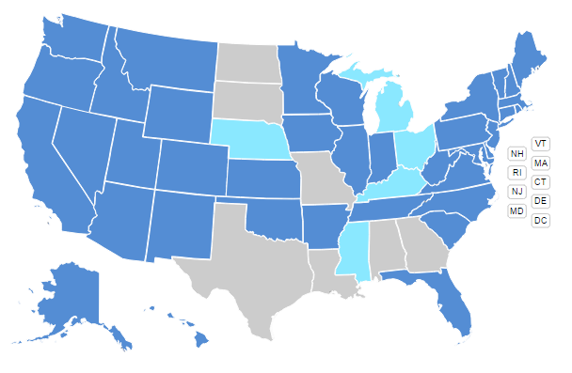
Joint Adoption Laws¹
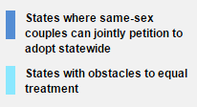

Second Parent Adoption Laws
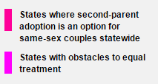

- Do you routinely ask a parent of a different last name to prove guardianship? A parent of the same last name? Does this differ if presumed parents are same or opposite sex?

- We often make assumptions in emergency care, explore personal biases
  - Do you routinely ask any opposite sex spouses for proof?
    - Do you consider the possibility of divorce or separation?
  - Would you allow a same-sex partner/spouse to make medical decisions in lieu of documentation of a medical power of attorney? If directed by patient to do so? How would you document this?
  - If a patient were to die who had a same-sex partner at the bedside can they make decisions about autopsy or body disposition?
    - If ME case not relevant initially
    - What is hospital policy?
    - What is legal?
      - In states without SSDP or same-sex marriage recognition often:
        - Adult child>parents>sibling>other

- Does your state:
  - Recognize same-sex marriage?
  - Recognize same-sex marriage performed in other states?
  - Recognize Domestic Partnerships?
  - Have laws allowing second parent adoption? Prohibit adoption by an LGBT person?
  - Protect against this family being denied a mortgage or evicted because the parents are lesbians?

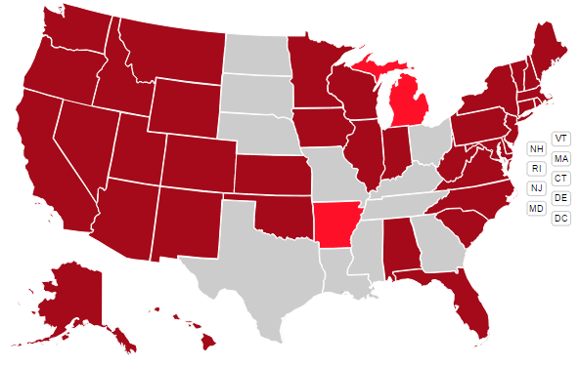
Marriage Equality and Other Relationship Recognition Laws
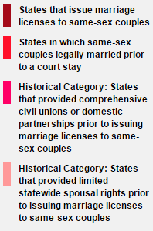

Joint Adoption Laws

Second Parent Adoption Laws

Housing Discrimination Laws

- The nurse who is taking care of one of the children states “I don't really want the other women involved, this special needs kid has enough problems without having two moms and no dad.” How do you react? Do you respond?

- Group should discuss their reaction to this statement
- Have they heard similar statements in their own ED?
- To what degree should personal values or opinions affect other peoples healthcare options or decisions?
- Ask for a definition of equitable healthcare. Is there any group in society, regardless or your values or opinions of them that should not receive equitable healthcare?

References:
1. Available at: http://www.hrc.org/state_maps. Accessed February 26, 2015.

Case 3

This is a case based on a true event, and likely countless others. It highlights concerns that LGBT professionals and professional students may have, especially in circumstances where they are not protected against discrimination on sexual orientation by policy or law.

- What advice do you give him?

- Check institution policies on discrimination based on sexual orientation (often available on website). This is common at many universities and healthcare employers
- Refer to states with legal protection against job discrimination
- Resources about coming out at Human Rights Campaign (HRC) (http://www.hrc.org/ ) and Parents and Friends of Lesbians and Gays (PFLAG) (http://community.pflag.org/Page.aspx?pid=194&srcid=-2)
- Family and friend reactions to coming out cab be unpredictable and can change over time. Often creates a conflict between belief system and personal knowledge of the LGBT person

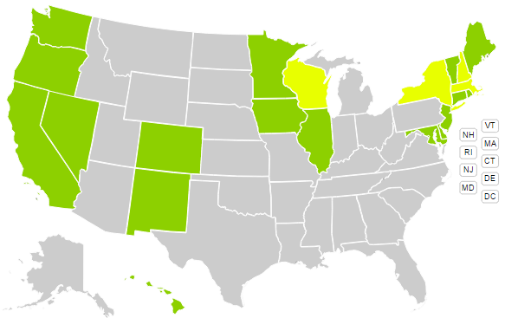

Public Accommodation Laws¹
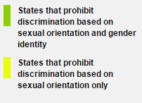

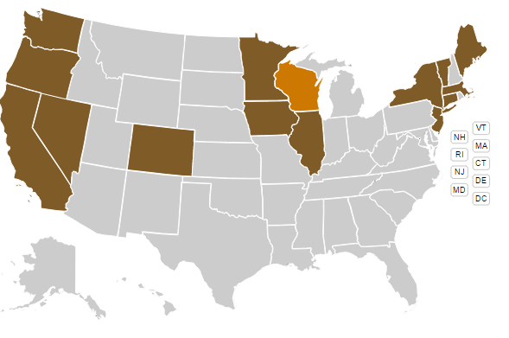
Student Discrimination Laws
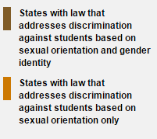

- Can a residency program discriminate against him in the Match because he is LGBT?

- See above regarding discrimination policies and laws
- Discuss whether being open in match process would be a benefit or a negative when interacting with prospective residencies. Would this advice change from a strong to weak applicant?

- Once matched, can his residency treat him differently because he is LGBT?

- See above regarding policies and law. If the institution does not have a policy against discrimination and the state does not have legal protection it is possible

- What resources exist for him to explore his legal rights?

- See HRC above
- Lamda Legal (http://www.lambdalegal.org/)

- How might he determine a programs commitment to diversity and inclusion?

- Does the institution have policy against discrimination based on sexual orientation
- Does the program offer any information online or with program information sent/or on interview day addressing commitment to diversity and inclusion
- Does the employer offer same sex domestic partner benefits

- Are you concerned for his well-being? Does being LGBT affect him differently than other students at this phase of their lives?

- Yes, LGBT people have higher rate of depression, suicide, and substance abuse
- Being “in the closet” can cause additional stressors during a high demand and stressful time of his professional career
  - Financial assistance from family as stated in case
  - Relationship stress with family and friends not knowing their reaction if he comes out and thus potential rejection by those he loves most
  - May affect career choice if certain specialties are seen as homophobic, thus affecting career satisfaction

References:
1. Available at: http://www.hrc.org/state_maps. Accessed February 26, 2015.

Case 4
- How should the physician address a transgender female-to-male patient with
a female name?

- If you as a physician are uncertain how to address the patient (i.e. name or pronoun) its best to simply ask the patient. For example, “Alice, what name would you like me to call you?’, or “Would you prefer me to refer to you as “him” or “her”?”
- Legally changing your name can be a somewhat involved process and has financial costs. (Starting at $139.00 on LegalZoom.com!)
- Changing your gender on your birth certificate is even more complicated depending upon the state involved. Some states require an “Affidavit for a New Birth Certificate After Completion of Gender Reassignment” to be filled out, and notarized, by your surgeon! What if you decide not to, or cannot afford, “surgical reassignment”?

- What are the legal ramifications of disclosing the patient’s HIV status?

- Despite the physician’s attempt to be understanding of Alice’s situation, HIPPA statues still apply and a patient’s health information may not be shared without permission of the patient.
- What should our well intentioned but indiscreet physician say now?
- How could he have done better?

- Should the physician speak-up when colleagues make inappropriate comments?

- Group should discuss their reaction to colleague’s statement
- Have they ever experienced such comments in their own emergency departments?
- Is it the role of the emergency physician to speak-up and correct other physicians? Or physicians to correct nurses? Or visa-versa? What about ancillary staff or medical students?
- Should inappropriate comments be forwarded to supervisors and not addressed as they occur?

- What must the hospital do when transgender female-to-male patients require admission for gynecologic reasons? Should that patient use the MALE or FEMALE restrooms?

- Does your emergency department have gender-free bathrooms?
- Do you think they are necessary?
- Where should Alice be admitted if the GYN ward is full of all female patients?
- What can hospitals do to avoid this delicate and uncomfortable situation?

